Lab 8

Objective: Replication of Pages based on Screenshots

Task 1 )

Replicate the Following Page – Images related to this page are stored in Task 1 Images Folder.

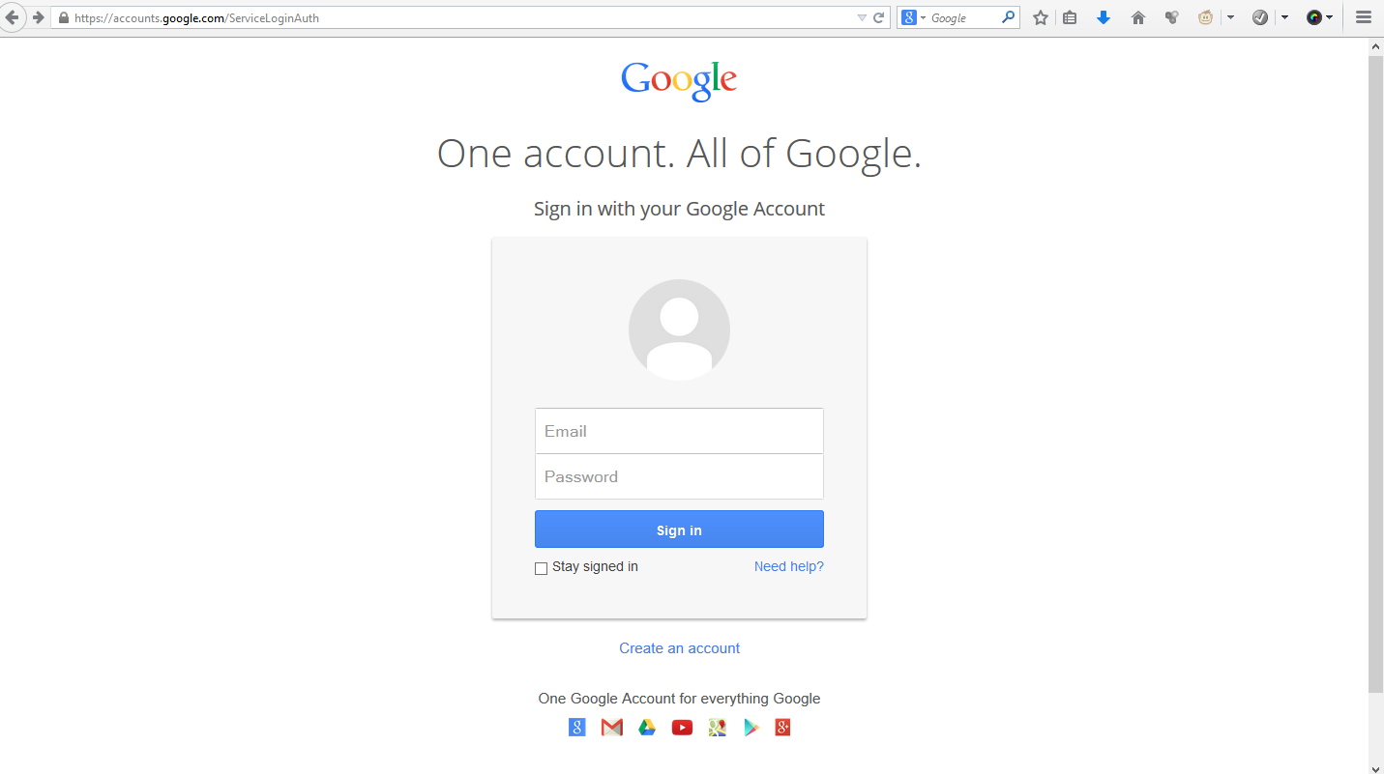

2) Replicate the Following Page

<https://gitter.im/apps>

Images used in this page are stored in Task 2 Images Folder.